
……UNIT …Tarampa State School – 2026
Year 5 K-6 Unit 2 |  | Subject / Learning Area - English |  |  |  |  |  |  | Unit Title – Examining, creating and sharing informative texts |  |  | Duration of Unit – Term 2– 10 Weeks
Overview of Unit | Students engage with a variety of informative texts, including reports, explanations, reviews and procedures written by Australian, First Nations Australian and world authors.  Through these texts, students examine how structural features, such as chapters, headings and subheadings, tables of contents, indexes and glossaries, help readers navigate and understand information. They apply their understanding by using these texts as models to create a report and present their work to an audience.
Assessment (summative) – what is being assessed | Assessment: 2  Information reports  Assessment purpose: To read, view and comprehend, and explain text structures, language features and visual features of informative texts. To create a written multimodal information report. To present a multimodal information report to an audience.
Achievement Standard – coloured text aspect of achievement standard being assessed  Monitoring – underlined is monitored aspect of achievement standard | Year 5  Speaking and listening  By the end of Year 5, students interact with others, and listen to and create spoken and/or multimodal texts including literary texts. For particular purposes and audiences, they share, develop and expand on ideas and opinions, using supporting details from topics or texts. They use different text structures to organise, develop and link ideas. They use language features including topic-specific vocabulary and literary devices, and/or multimodal features and features of voice.  Reading and viewing  They read, view and comprehend texts created to inform, influence and/or engage audiences. They explain how ideas are developed including through characters, settings and/or events, and how texts reflect contexts. They explain how characteristic text structures support the purpose of texts. They explain how language features including literary devices, and visual features contribute to the effect and meaning of a text.  Writing and creating  They create written and/or multimodal texts, including literary texts, for particular purposes and audiences, developing and expanding on ideas with supporting details from topics or texts. They use paragraphs to organise, develop and link ideas. They use language features including complex sentences, tenses, topic-specific vocabulary and literary devices, and/or multimodal features. They spell using phonic, morphemic and grammatical knowledge.
 | Year 5
Relevant content descriptions | Language  Language for interacting with others  • understand that language is selected for social contexts and that it helps to signal social roles and relationships (AC9E5LA01)  • understand how to move beyond making bare assertions by taking account of differing ideas or opinions and authoritative sources. (AC9E5LA02) Writing and creating  Text structure and organisation  •describe how spoken, written and multimodal texts use language features and are typically organised into characteristic stages and phases, depending on purposes in texts AC9E5LA03 Speaking and listening Reading and viewing  Writing and creating  • understand how texts can be made cohesive by using the starting point of a sentence or paragraph to give prominence to the message and to guide the reader through the text (AC9E5LA04)  Reading and viewing Writing and creating  Language for expressing and developing ideas  • understand that the structure of a complex sentence includes a main clause and at least one dependent clause, and understand how writers can use this structure for effect. (AC9E5LA05) Reading & viewing Writing & creating  • understand how noun groups can be expanded in a variety of ways to provide a fuller description of a person, place, thing or idea. (AC9E5LA06) Reading & viewing Writing & creating  • Explain how the sequence of images in print, digital and film texts have an effect on meaning. (AC9E5LA07) Speaking & listening Reading & viewing Writing & creating  • understand how vocabulary is used to express greater precision of meaning, including through the use of specialist and technical terms, and explore the history of words. (AC9E5LA08) Speaking and Listening Reading & viewing Writing & creating  • use commas to indicate prepositional phrases, and apostrophes where there is multiple possession  AC9E5LA09  Reading and viewing  Writing and creating |  |  | Literature  Literature and contexts  • identify aspects of literary texts that represent details or information about historical, social and cultural contexts in literature by First Nations Australian, and wide-ranging Australian and world authors. (AC9E5LE01) Reading & viewing  Engaging with and responding to literature  • present an opinion on a literary text using specific terms about literary devices, text structures and language features, and reflect on the viewpoints of others (AC9E5LE02 Writing and creating  Examining literature  • recognise that the point of view in a literary text influences how readers interpret and respond to events and characters. (AC9E5LE03) Reading & viewing  • examine the effects of imagery, including simile, metaphor and personification, and sound devices in narratives, poetry and songs. (AC9E5LE04) Speaking & listening Reading & viewing  Creating literature  • create and edit literary texts, experimenting with figurative language, storylines, characters and settings from texts students have experienced (AC9E5LE05) Speaking and listening Writing and creating |  |  |  |  |  |  | Literacy  Texts in context  • describe the ways in which a text reflects the time and place in which it was created. (AC9E5LY01) Reading & viewing  Interacting with others  •use appropriate interaction skills including paraphrasing and questioning to clarify meaning, make connections to own experience, and present and justify an opinion or idea (AC9E5LY02)  Analysing, interpreting and evaluating  • explain characteristic features used in imaginative, informative and persuasive texts to meet the purpose of the text. (AC9E5LY03) Reading & viewing  • navigate and read texts for specific purposes, monitoring meaning using strategies such as skimming, scanning and confirming. (AC9E5LY04) Reading & viewing  • use comprehension strategies such as visualising, predicting, connecting, summarising, monitoring and questioning to build literal and inferred meaning to evaluate information and ideas. (AC9E5LY05) Reading & viewing  •plan, create, edit and publish written and multimodal texts whose purposes may be imaginative, informative and persuasive, developing ideas using visual features, text structure appropriate to the topic and purpose, text connectives, expanded noun groups, specialist and technical vocabulary, and punctuation including dialogue punctuation AC9E5LY06 Writing and creating  •plan, create, rehearse and deliver spoken and multimodal presentations that include relevant, elaborated ideas, sequencing ideas and using complex sentences, specialist and technical vocabulary, pitch, tone, pace, volume, and visual and digital features AC9E5LY07 Speaking and listening  •use phonic, morphemic and vocabulary knowledge to read and spell words that share common letter patterns but have different pronunciations  AC9E5LY08 Reading and viewing  Monitoring strategy – Writing and creating  •build and spell new words from knowledge of known words, base words, prefixes and suffixes, word origins, letter patterns and spelling generalisations  AC9E5LY09 • Write linked paragraphs with basic supporting detail.BC  Monitoring strategy – Writing and creating  •explore less common plurals, and understand how a suffix changes the meaning or grammatical form of a word  AC9E5LY10  Monitoring strategy – Writing and creating
UNIT OVERVIEW – TEACHING AND LEARNING AND ASSESSMENT
Week 1 | Week 2 | Week 3 | Week 4 | Week 5 | Week 6 | Week 7 | Week 8 | Week 9 | Week 10
Sequence 1 |  | Sequence 2 |  | Sequence 3 |  | Sequence 4 |  | Sequence 5
Examining, creating and sharing informative texts
 |  |  |  |  |  | Year 5 Assessment Task 2

Moderation – identify opportunities to moderate at multiple junctures (when/who with/ what / next steps etc) | Week 5 -6 Term TBC  Before (before assessment takes place and at the planning stage)  Aligning targeted aspects of the achievement standard being assessed with appropriate curriculum elements.  Calibrating understandings about how to make judgements using sample student or teacher created sample responses to summative assessment.  Quality assuring the teaching and learning sequence and reviewing the selection of pedagogical approaches, practices and teaching strategies to differentiate teaching and learning. |  |  | Term 2 Week 8 TBC  After (after assessment takes place but before it is graded)  Calibrating judgements about student work by grading sample student responses to summative assessment, representing evidence at, above and below the ‘C’ standard against the targeted aspects of the achievement standard being assessed.  Confirming judgements about student work by moderating sample student responses to summative assessment, representing evidence at ‘A’, ‘B’, ‘C’, ‘D’, ‘E’ (or equivalent) levels of achievement – against the targeted aspects of the achievement standard being assessed.  Using calibrated and confirmed teacher judgements to award a overall level of achievement for summative assessment for all students |  |  |  |  |  |  | Term 3 Week 2 TBC – Folio (Marker Students  End (Engaging in moderation processes at the End of the reporting period.)  Calibrating judgements for reporting by grading sample assessment folios, representing evidence at, above and below the ‘C’ standard.  Confirming judgements for reporting by moderating sample student assessment folios, representing evidence at ‘A’, ‘B’, ‘C’, ‘D’, ‘E’ (or equivalent) level of achievement – against the targeted aspects of the achievement standard taught and assessed in the reporting period.  Using calibrated and confirmed understandings about making standards-based judgements on folios to ensure accuracy of judgements for reporting on student achievement for all students.
What do my students need to know / understand? |  |  |  |  |  | What do my students need to be able to do?
Year 5 Know (Knowledge / Understanding)  Speaking and Listening  A standard  - Different text structures organise, develop and link ideas.  - Multimodal and voice features enhance presentations.  B standard  - Text structures develop ideas.  C standard  - Presentations inform audiences using planned ideas.  Reading and Viewing  A standard  - Characteristic structures support purpose.  - Language and visuals contribute to effect and meaning.  B standard  - Structures and features influence meaning.  C standard  - Texts include structures and features that help readers.  Writing and Creating  A standard  - Paragraphs organise, develop and link ideas.  - Complex sentences, tense and vocabulary expand ideas.  B standard  - Paragraphs and language features develop ideas.  C standard  - Information reports present ideas for an audience. |  |  |  |  |  | Year 5 Do (Skills / Application)  Speaking and Listening  A standard  - Present a multimodal report with expanded ideas.  - Use precise vocabulary and effective voice features  B standard  - Present sequenced ideas with supporting detail.  C standard  - Share organised information using simple structure.  Reading and Viewing  A standard  - Explain how structures support purpose.  - Explain how language and visual features affect meaning.  B standard  - Describe how structures/features support meaning.  C standard  - Identify key structures and features.  Writing and Creating  A standard  - Create a report with supporting detail.  - Use coherent paragraphs and precise vocabulary.  - Edit for clarity.  B standard  - Write organised paragraphs with supporting details.  C standard  - Write linked paragraphs with basic supporting detail.
Differentiation

How will I cater for the needs of all my students? How will I Include all of my students in the teaching, learning and assessment process? What reasonable adjustments / special provisions do I need to consider? How will I differentiate around environment, process, content and product (Maker model)?

Students below  *Please in yellow marker highlight student/s for each year level |  |  | Students at |  |  |  |  |  |  | Students above
Special provisions in the conditions of assessment are applied consistently across the school. All students are entitled to demonstrate their knowledge, understanding and skills in response to assessments. Schools and teachers support all students to participate in assessment and demonstrate the full extent and depth of their learning. Special provisions in the conditions of assessment reflect differentiation, or adjustments, made to curriculum delivery. Special provisions are not adjustments to the relevant achievement standard on which student work is judged. They do not involve compensating for what the student does not know or cannot do (DoE 2018, p. 3). |  |  |  |  |  |  |  | 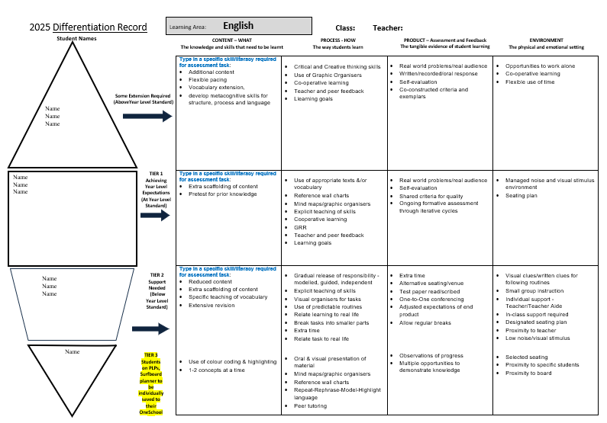
Types of special provision:  Special provisions in the conditions of assessment may include…  • presentation – changing how an assessment appears or is communicated to a student from the regular format. E.g. being read to rather than reading unless reading itself is what is being assessed.  • response – allowing students to complete assessments in different ways such as using computer software or an assistive device to solve and organise problems when this does not compromise what is specifically being assessed.  • setting – changing location including the physical or social conditions in which the assessment is completed.  • timing – allowing the student a longer time to complete the assessment, or change the way the time is organised or when the assessment is scheduled. |  |  |  |  |  |  | Maker’s Model based on Tomlinson’s work  Who should be considered for special provisions?  Any student who has a specific educational need may be considered for special provision including students…  - with educational needs arising primarily from socio-economic or cultural factors  - with disability such as those of a sensory, motor and/or neurological nature  - for whom English is an Additional Language or Dialect (EAL/D)  who are gifted or talented with short-term impairments such as glandular fever or fractured limbs.
Student/s requiring an ICP

 | Teaching and Learning Sequence |  |  |  | Reading |  |  |  |  |  | Differentiation |  | Resources
Week 1  Sequence 1 | Learning Objective:
Week 2
Sequence 1 continued…

Week 3
Sequence 2

Week 4
Sequence 2 continued
Week 5
Sequence 3
Week 6
Sequence 3 continued…
Week 7
Sequence 4
Week 8
Sequence 4 continued
Week 9
Sequence 5

Week 10  Sequence 5 ssS | ^{Review}
Monitor
End of Unit Notes / Reflection
What worked well?

What requires adjustment for 2027?

